­

Machine Learning

BUITEMS

Computer Engineering

Department of

**0**

**ASSIGNMENT NO 1**

**Assignment: 01**

**Make sure you confirm that Anaconda is installed and working by opening a terminal win**

**1.1: Task 1**

In your terminal, run

>> conda info

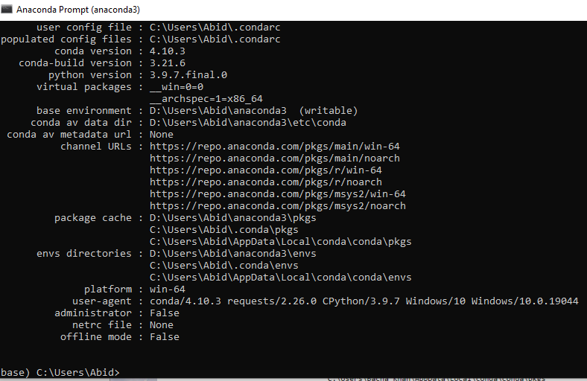

**3.1: Task 2**

Run the following script in IPython and paste the figure created by the script into your report

import matplotlib.pyplot as plt

plt.plot([1,2,3,4], [1,2,7,14])

plt.axis([0, 6, 0, 20])

plt.show()

CODE:

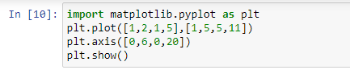

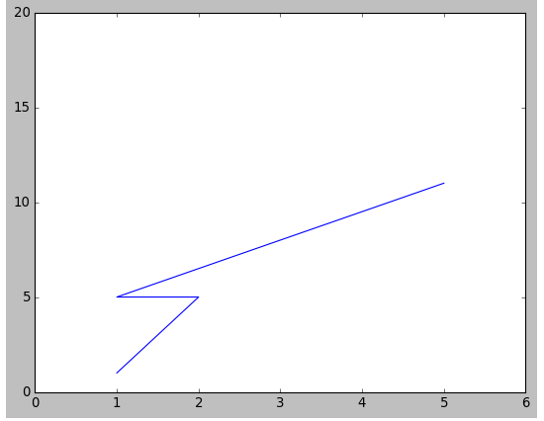

**3.1: Task 3**

Use Matplotlib to create a figure of your choice in IPython. Paste your code

and figure it into your report

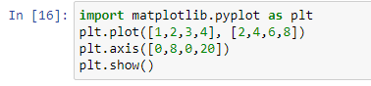

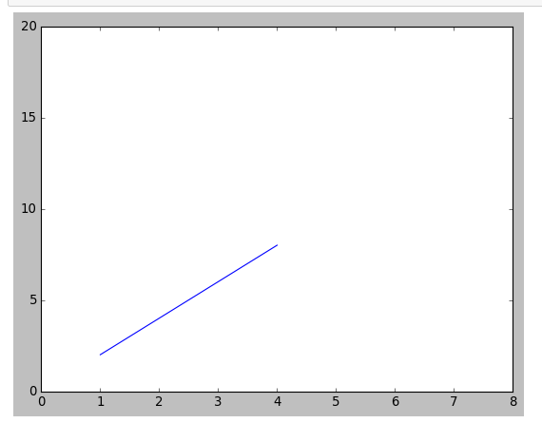

**4.1: Task 4**

Register for a student account here for free private repository access for future projects and go through these tutorials. insert a screenshot of your user page i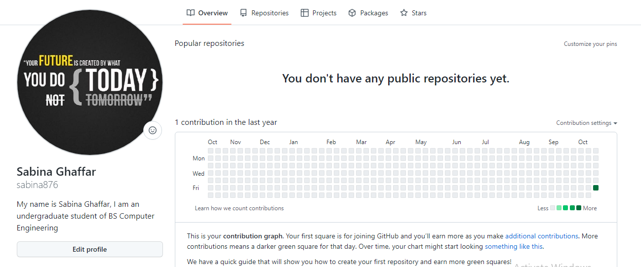n GitHub in your report.